Street Medic Starter Booklet
BASICS
Do:
- Have a clearly visible first aid cross (can use duct tape if needed) - ideally, white or red in color
- Wear a marked vest (provided if you don't have one) - first aid cross or red in color
- Keep your gear simple and effective (the more you carry, the heavier it will be)
- Situational awareness & maximizing responder safety is the first step for any intervention. What clothing and gear you have, and how they are packed/organized will affect your ability to maximize your own safety, and therefore your ability to help as many people as possible. We cannot help others if we do not take appropriate steps to protect ourselves.
Do NOT:
- Wear contacts
- Wear a bright yellow or any other bright colored vest
Notes:
- For planned rallies/protests/etc. that are not scheduled to be covered by 50501: Buddy up, let the chat know how the conditions are and report anything that would include mass injury or anything abnormal. If you're running solo, be safe and keep the chat updated

GEAR & SUPPLIES
PPE, standard
- Mask: N95 or KN95 - good enough to block >95% of fine particulates. Good for infectious protection, will not sufficiently block gases (tear gas; CS) and oil-based aerosols (pepper spray)
- Head protection: bump cap (https://a.co/d/4ZmA5iG) - these slide/hide inside standard hats
- Ear protection: ear plugs with >30 decibel rating (LRAD devices can emit up to 160 decibels; >130 decibel sounds are risk of immediate/permanent hearing loss).
- Gloves
  - Nitrile gloves - wear to protect against bodily fluid exposure
  - Mechanic/extrication gloves: not for warmth - meant for protection against cuts and burns
    - Cut and heat resistant (https://a.co/d/78yiagp)
    - HexArmor also makes really good stuff, but they're a bit pricier
- Clothing
  - Long sleeves and long pants
    - provides skin protection against potential chemical irritants
  - Winter clothing note - dress in layers. General philosophy:
    - Base layer: moisture wicking materials to keep sweat or wetness off your skin. merino wool, synthetic fabrics (examples: polyester, spandex, polypropylene, nylon, acrylic, gore-tex)
    - Mid-layer: insulation to trap body heat (examples: fleece, down, synthetic materials)
    - Outer-layer: water- and wind-proof materials
  - Short sleeves and long pants in the summer
- Shoes/boots
  - Comfortable for running
  - Seasonal socks (to keep your feet warm and/or dry)
- Supply bag
  - Backpack (many find easier to carry)
    - Find a pack that has good shoulder and hip support. These packs generally have both nice shoulder padding, a sternum strap (buckle across the upper chest), and a thick padded hip belt/buckle. Pack straps & packing should be done so the weight is close to body and distributed on hips, not upper back/shoulders
    - Clam-shell style packs are preferable vs. top loading styles, as it is easier to quickly get access to most of the contents of the large pockets, including what is stored on the bottom
  - Over the shoulder bag
  - Large fanny pack for quick grab supplies
PPE, increased risk/hazard
- Mask: need P100 o/v (organic vapor) protection for eyes, nose, mouth due to increased risk of tear gas or pepper spray
  - Masks: Respirators come in small, medium, and large. We will have some to try.
    - Half face https://a.co/d/46ZywYb - need to pair this with googles, see below
    - Full face https://a.co/d/6CLywEz
    - P100 o/v (organic vapo) filters https://a.co/d/0C9YSbR
- Goggles
  - Impact resistant (ANSI Z87.1+ ideal)
  - Unvented if possible
  - https://a.co/d/fDpfJ6J
- Head protection
  - Helmet: Bicycle, motorcycle or hard hat
- Ear protection: in addition to ear plugs as above, consider over the ear muffs - especially if going to a location LRAD may be deployed
- Knee pads or pants with integrated pads
- Body armor (very optional – heavy, expensive, uncomfortable, may be intimidating to patients )
  - Soft armor - up to level IIIa good for pistol rounds, lighter, more comfortable
  - Hard plate armor - up to level IV - good for rifle rounds, heavier, rigid, less comfortable
Radio
- We recommend the Baofeng FRS-A1 radios: (https://a.co/d/gzXqQ2J)
  - These will need to have privacy codes programmed so other team members can hear you.
  - Recommended for beginners??

Packing List
- Gauze, roll or 4”x 4” pads
- Medical tape, 1”
- Band-aids, L or XL
- Mylar blanket
- Disposable hand warmers (winter)
- Head lamp or pen light
- Electrolyte / sugar tabs or packets
  - add to water for people with signs or symptoms of dehydration or low blood sugar levels
  - liquid IV, Nuun are good and compact brand options

Items to pack in a quick access location
- CPR face mask
- Hand sanitizer
- Nitrile gloves
- Water for wound rinsing and decontamination
  - Squeezable reusable plastic water bottle works well, or disposable water bottles and safety pin for puncturing caps
  - Gatorade 32 oz. Contour Squeeze Bottle | Dick's Sporting Goods
- Stop the Bleed kit: Gauze, CAT Tourniquet, Sharpie (to write time of application on the tourniquet)

Niche medicines (only if within your scope & expertise) - Largely avoid giving any meds.
- Albuterol inhaler & spacer: CS (tear gas) is an asthma / reactive airway trigger
- Tylenol/Ibuprofen single dispense pouches
- Narcan: symptoms of opioid overdose include a combination of unresponsiveness, slow/no breathing, blue/grayish skin (particularly around lips & fingertips), pinpoint pupils, choking/gurgling sounds
- Allergic & anaphylactic reaction treatments
  - Benadryl cream - good topical/local option for folks following bee stings (summer months)
  - Epi-pen or liquid Benadryl - for signs and symptoms of anaphylaxis

Other helpful links
§ https://mn50501medics.printful.me
§ Products With A Mission | North American Rescue
§ Rescue Essentials | Emergency Medical Supplies, Kits & More
§ Home | ACS Stop the Bleed
§ Tactical Emergency Casualty Care
§ Major Haemorrhage in Trauma • LITFL • CCC Trauma

SKILL LEVELS – EXPECTATIONS
Basic First Aid | Skilled Care (only if within your scope!)
Use PPE | Diagnostics: BP cuff/Stethoscope/Pulse Ox/Glucometer/Pen light
Basic wound care | Meds: EpiPen, Narcan, Albuterol
Eye care – flush | Vented chest seal, needle thoracostomy
Hand sanitizer, wipes | Ambu-Bag, airways
Snacks, water | Stretcher use
Ice packs | C collar
BLS/CPR – with CPR mask | Splinting
Stop the bleed – tourniquet, trauma sheers, wound packing
Emergency blanket
Tylenol (can offer but have person take it themselves)
Primary Survey (CABCDE)
https://www.ncbi.nlm.nih.gov/books/NBK430800/
https://promedcert.com/blog/primary-acls-survey
C - Catastrophic Hemorrhage: Identify and control any life-threatening external bleeding. Apply direct pressure, use haemostatic dressings, or tourniquets as necessary. This step is crucial as uncontrolled bleeding can lead to rapid deterioration and increased mortality.
A - Airway: Assess and ensure the airway is clear and patent. If there are any obstructions (e.g., from the tongue or foreign bodies), take immediate action to secure the airway, especially in cases of suspected cervical spine injury.
B - Breathing: Evaluate the adequacy of breathing. Look for signs of respiratory distress, and assess for conditions like pneumothorax or hemothorax. Provide supplemental oxygen and consider interventions such as intubation if necessary.
C - Circulation: Check for circulation and control any significant bleeding. Assess the patient's hemodynamic status, looking for signs of shock. Initiate fluid resuscitation as needed to maintain adequate perfusion.
D - Disability: Perform a quick neurological assessment to determine the patient's level of consciousness and identify any potential traumatic brain injuries. Use the Glasgow Coma Scale (GCS) for evaluation.
E - Exposure: Fully expose the patient to identify any hidden injuries while preventing hypothermia. This involves undressing the patient and carefully examining all areas of the body.

CHEMICAL IRRITANT TREATMANT
1. Leave area, decontaminate, prevent exposure
2. There is no treatment to shorten symptoms – only time can remit symptoms
3. Target: Eyes, Nose, Mouth, Airway
4. Prevention: Goggles, Mask, clothing, gloves
5. Treatment:
- Use high pressure stream to mechanically flush the eyes
- The solution to pollution is dilution
- Just use water!
STOP THE BLEED
1. Apply 2-3 inches above wound on long bone
2. Do not place on elbow or knee
3. Tighten until bleeding stops
4. Write time down (sharpie!)
5. Do NOT remove until hospital
6. Can apply to others or on yourself
7. Can be applies over clothes
8. Can use two if needed
9. Tourniquets HURT
10. Same tourniquet for kids
11. If TQ too big, direct pressure/packing work
12. Children have lower blood pressure
13. Gold standard – CAT TQ (combat application tourniquet) by NAR - $30/each

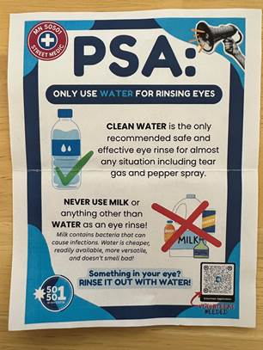

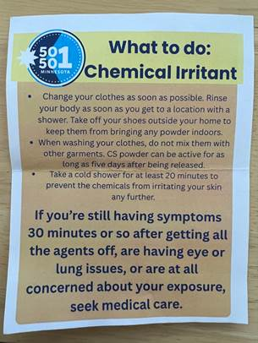
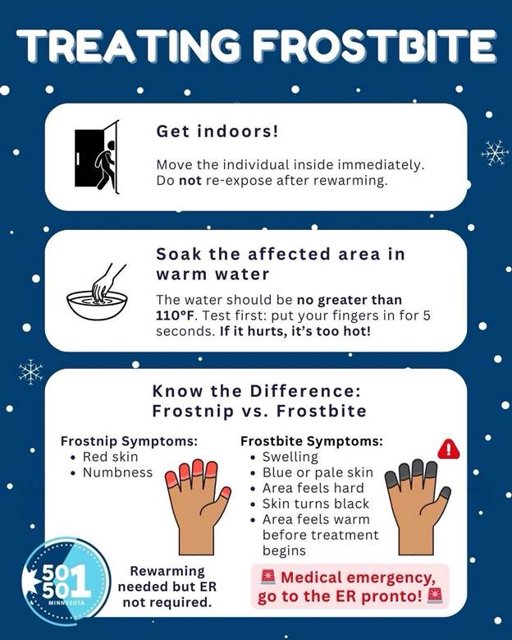
Hearing protection
LRAD (long range acoustic device)
- Originally developed and optimized by US Navy after USS Cole bombing in 2000
- Purpose: long-range, clear communication (and now: crowd control)
- 100-10,000 Hz frequencies
  - Low frequency = penetrates obstacles and barriers
  - Higher frequency = ensures voice messages are understandable
- Can go up to 160 decibels in intensity
- >120-130 decibels causes immediate pain and risk of immediate, permanent hearing loss
- THEREFORE, need at minimum accessible hearing protection that can reduce >30 db
  - Many generic ear plugs are rated >30 db. putting these on, in conjunction with covering ears tight with hands, may be sufficient to minimize risk of damage against a deployed LRAD.
  - Best protection is avoidance - rapidly get away of the line of the LRAD. If needing to dodge, run to the SIDE (perpendicular) of the direction LRAD is aimed. It is a tight beam, not wide/broad. They were built to transmit voices in the clear >km away, you won't out-run the thing by turning around and going backwards.
  - If going to places that have high likelihood of LRAD deployment, consider stronger noise cancelling earmuffs/headphones that go over ear (can use these & ear plugs simultaneously for multiple layers of protection)
